

**Introduction to Database System**

**F22**

# **Mid Term Lab**

# **VERSION I**

**Time Allowed: 2 hours**

|  |  |
| --- | --- |
| Name: |  |
| Registration No |  |
| Serial Number (of attendance sheet) |  |

|  |  |  |  |  |
| --- | --- | --- | --- | --- |
|  | ERD | DML | DDL | Total |
| Total Marks | 10 | 20 | 20 | 50 |
| Obtained Marks |  |  |  |  |

**Instructions:**

1. **This is a closed book, closed notes paper.**
2. **Understanding questions is part of the paper**. Therefore, no queries will be entertained during examination.
3. Schema file is uploaded on teams/portal. Use those files to attempt the DML section of paper.
4. Use proper indentation/formatting while writing queries. Not properly indenting will deduct 5% marks.
5. **You need to make an MS Word with your name and registration should be mentioned on each page.**
6. **You need to write only queries with output in MS Word file, you need to write query (text form) + its output table (picture) if any.**
7. **You will solve the DDL + DML section only in word docx.**

# **Part 1 ERD** **[10 Marks]**

**Draw ERD Diagram on paper.**

Consider an ONLINE_AUCTION database system in which members (buyers and sellers) participate in the sale of items. The data requirements for this system are summarized as follows:

■ The online site has members, each of whom is identified by a unique member number and is described by an e-mail address, name, password, home address, and phone number.

■ A member may be a buyer or a seller. A buyer has a shipping address recorded in the database. A seller has a bank account number and routing number recorded in the database.

■ Items are placed by a seller for sale and are identified by a unique item number assigned by the system. Items are also described by an item title, a description, starting bid price, bidding increment, the start date of the auction, and the end date of the auction.

■ Items are also categorized based on a fixed classification hierarchy (for example, a modem may be classified as COMPUTER → HARDWARE → MODEM).

■ Buyers make bids for items they are interested in. Bid price and time of bid are recorded. The bidder at the end of the auction with the highest bid price is declared the winner, and a transaction between buyer and seller may then proceed.

■ The buyer and seller may record feedback regarding their completed transactions. Feedback contains a rating of the other party participating in the transaction (1–10) and a comment

Draw an ERD Diagram.

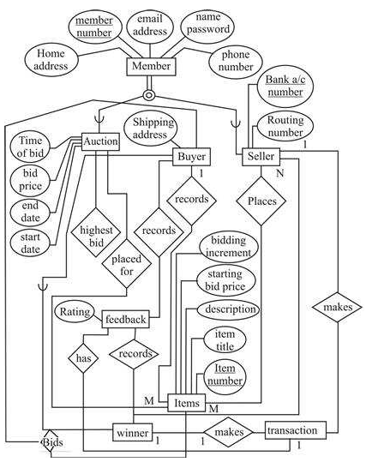

# **Part 2 DDL** **[20 Marks]**

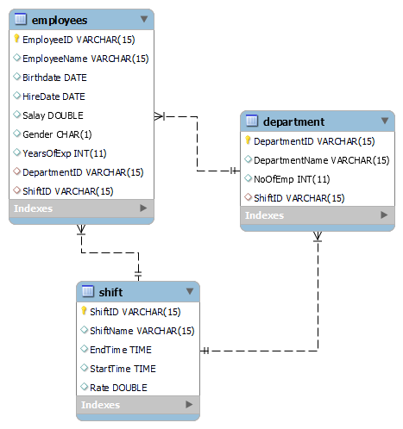

**Q1.** Implement the above tables with its attributes. Make Primary Key in all three tables. **[6 Marks]**

**Q2.** Make required relations using alter command **[6 Marks]**

**Note:**

* DepartmentID in **Employees** table, should be foreign key from **Department** table.
* ShiftID in **Employees** table, should be foreign key from **Shift** table.
* ShiftID in **Department** table, should be foreign key from **Shift** table.

**Q3.** Change the variable name of salary to “Pay” and datatype from double to int in **Employees** table. Note: Do these in one Query only. **[4 Marks]**

**Q4.** Set default value of ShiftName in **Shift** table to “Morning”. **[4 Marks]**

**Part 3 (DML)** **[20 Marks]**

* **Import ClassicModel.sql schema.**

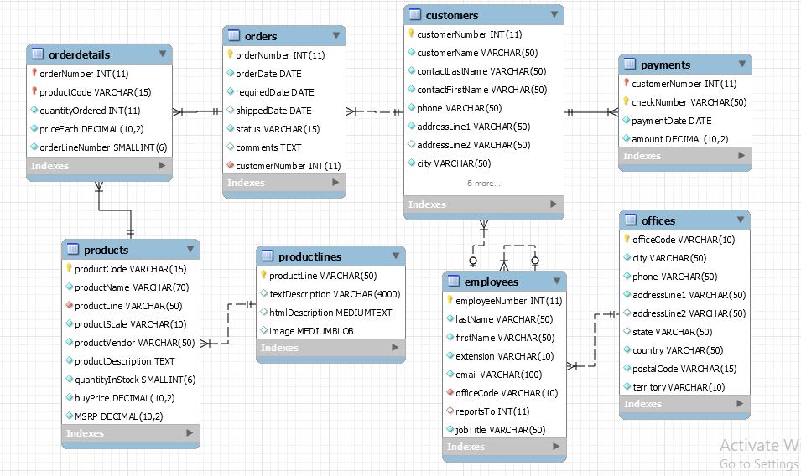

**Solve the following questions from the above schema:**

1. Select all employees with FIRST_NAME starting from ‘B’. (Like)
2. show record of employee where job titles contains “manager”. (Like)
3. Show all products where buy price is in range of 50 to 70. (between)
4. Display average buy price of all classic cars. (avg)
5. Select and count all payments where payments are made in and after 2004.
6. Show all customers that are not from “Poland, Norway, Germany”.